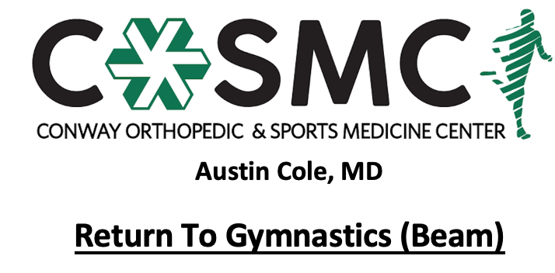

Criteria to initiate program:
- Proper alignment and eccentric control with bilateral and unilateral closed chain movements.
- Perform Upper Extremity Functional Test at >70% to initiate Phase I if upper extremity injury.
- Single leg single hop test and single leg press >70% on Limb Symmetry Index.
- Able to perform full plank position pain free for 60 seconds with proper technique.

Key notes:
- Perform program on every other day basis to allow for 24-48 hours recovery time.
- Perform each phase for 2-3 sessions before moving on to next phase- move to next phase once able to complete with proper mechanics, good strength, and without symptoms.
- Athletes will progress at different rates through the program dependent upon confidence, degree of inflammation, severity of injury, age, and type of surgical intervention. Pain and swelling are the best guides to determining tolerance at each phase and whether an athlete should progress to the next step. Progression through the phases is combined evaluation and guidance of rehab provider and coach.
- Setbacks are common during return to sport progressions and sound judgment should be used regarding an extra rest day(s) or regressing back to prior phase if pain and swelling are problematic.
- Continue with strengthening exercises 2-3 times a week while progressing program- strengthening exercises may overlap days of program and be performed after program; however, must have one complete rest day per week.
- Active warm-up in class to initiate each session with cooldown following. Ice for 10-15 minutes following session as pain and swelling dictate.
- Start with spotter initially and as needed throughout progression.
- Start on foam balance beam on floor surface, low profile beam, or beam surface expander (usually 8 inches wide) to regain confidence and focus on technique.

Phase I:
- Knee scale
- Front scale
- Side scale
- Back scale
- V support sit
- Forward roll
- Backward shoulder roll
- Handstand
- Cartwheel
- Half turn on one foot

Phase II:
- Body weave
- Handstand forward roll
- Full turn on one foot
- Back walkover
- Straight jump
- Tuck jump
- Split jump
- Straight jump with ½ turn
- Wolf jump
- Tuck jump with ½ turn
- Pike jump
- Straddle jump

Phase III:
- Roundoff
- Hitch kick
- Wolf jump with ½ turn
- Wolf jump with full turn
- Straddle jump with ½ turn
- Sissone
- Cat leap
- Split leap
- Cap leap with ½ turn
- Switch split leap
- Front handspring
- Back handspring

Phase IV:
- Aerial
- Front tuck
- Front pick
- Front layout
- Back tuck
- Back pike
- Back layout
- Gainer Salto to side of beam
- Gainer Tuck Salto off end of beam
- Double tuck dismount off beam

Phase V:
- Perform full skill set and routine with dismount on 8 inch mat progressed to 4 inch mat progressed to competition regulation mat (usually 2 inch mat)

