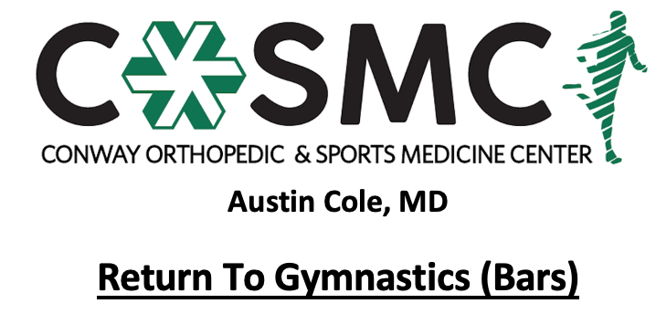

Criteria to initiate program:
- Proper alignment and eccentric control with bilateral and unilateral closed chain movements.
- Perform Upper Extremity Functional Test at >70% to initiate Phase I.
- MMT 5/5 and pain free in all directions.
- Able to perform full plank position pain free for 60 seconds with proper technique.

Key notes:
- Perform program on every other day basis to allow for 24-48 hours recovery time.
- Perform each phase for 2-3 sessions before moving on to next phase- move to next phase once able to complete with proper mechanics, good strength, and without symptoms.
- Athletes will progress at different rates through the program dependent upon confidence, degree of inflammation, severity of injury, age, and type of surgical intervention. Pain and swelling are the best guides to determining tolerance at each phase and whether an athlete should progress to the next step. Progression through the phases is combined evaluation and guidance of rehab provider and coach.
- Setbacks are common during return to sport progressions and sound judgment should be used regarding an extra rest day(s) or regressing back to prior phase if pain and swelling are problematic.
- Continue with strengthening exercises 2-3 times a week while progressing program- strengthening exercises may overlap days of program and be performed after program; however, must have one complete rest day per week.
- Active warm-up in class to initiate each session with cooldown following. Ice for 10-15 minutes following session as pain and swelling dictate.
- Start with spotter initially and as needed throughout progression.

Phase I:
- Inverted hold progressed into inverted push ups
- Perform L-hang on bars
- Perform chin up hang
- Jump to front support
- Forward roll to chin up or L hang

Phase II:
- Able to walk on hands in handstand position
- Handstand hops
- Casting
- Cast away to stick
- Cast to horizontal position
- Cast to above horizontal position
- Candlestick on floor bar
- Underswing
- Cast back hip circle
- 2 back hip circles consecutively
- Cast to straddle sole circle dismount
- Cast to pike sole circle dismount
- Cast to squat on
- Single leg shoot through
- Mill circle forward
- Front hip circle
- Straight body hang and walk hands across bar
- Re-grip swings

Phase III:
- Pike glides
- Straddle glides
- Jump to low bar and then glide in pike straddle
- Glide kip
- Tap swings

Phase IV:
- Jump to high bar and long hang pullover
- Jump to high bar and long hang kip
- Underswing into baby giant
- Straddle underswing to high bar
- Pike underswing to high bar
- Underswing into giants
- Pak salto
- Perform flyaway dismount on pit bar into foam pit
- Perform dismounts on pit bar into foam pit

Phase V:
- Perform full skill set and routine with dismount on 8 inch mat progressed to 4 inch mat progressed to competition regulation mat (minimum 1.25 inch depth)

